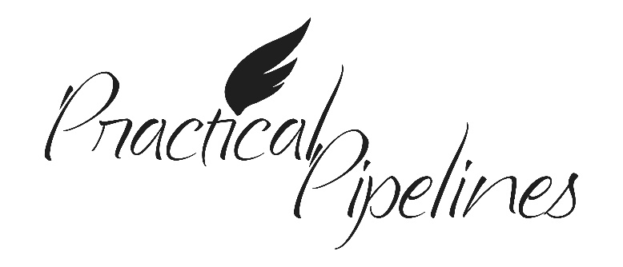**TRAINING ANNOUNCEMENT**

***Practical Pipelines***, is a unique multi-media training that contains actual 911 and response footage of the Danielle Dawn Smalley pipeline incident. This brief multi-media training provides information specific to your county pipelines and also reviews the following key messages:

* Pipeline Systems Today
* Pipeline Product Characteristics and Hazards
* Pipeline Locations and Operators in Your County
* Pipeline Damages in Texas
* Consequences of Unpreparedness
* Emergency Response

Trainees will leave with a new perspective of pipelines that they can apply to their everyday mission of public safety, access to materials and resources for pre-planning, CEU credit potential and much more.

Date:

Time:

Location:

*Can’t make it? Ask your Chief or Training Officer how you can complete the training on your own and be included on the roster.*