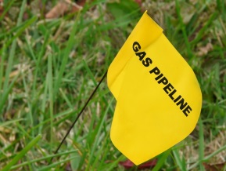
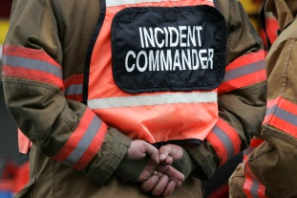

PRACTICAL PIPELINES TRAINING DESCRIPTION 2019

TRAINING DESCRIPTION
Our goal is to change the attitude of first responders from “preparing for a rare situation” to considering pipelines a part of everyday public safety and to influence behaviors (such as continuous training, advance preparedness, prevention and coordinated response) that strengthen the safety network around pipelines in their communities.
- 50-minute State and County Specific Training Video with Segment Questions for Message Reinforcement
- Interactive Video Transcript of Content with Links to Additional Training Opportunities and Resources
- Online Toolkit: County-Specific Downloadable and Printable Materials (for training, preparedness and emergency response use)
- Links to Sponsor Webpages or Portals
PROGRAM OBJECTIVES
- Increasing understanding of the state of the pipeline system today among first responders
- Reviewing common pipeline products, leak characteristics, and hazards of a release
- Demonstrating how first responders can use markings and online tools to locate pipelines in their communities
- Inspiring first responders to take a proactive role in preventing pipeline emergencies that could lead to loss of life, property, or harm to the environment
- Instilling the importance of advance preparedness by revealing common pipeline emergency response deficiencies and failures
- Empowering first responders to successfully work with pipeline operators for improved coordinated emergency response
METHOD OF INSTRUCTION
Video, Discussion and Digital Materials

INSTRUCTOR(S)
Agency providing training self via Practical Pipelines from the Danielle Dawn Smalley Foundation

TRAINING OUTLINE
INTRODUCTION
- The Story and Mission of the Danielle Dawn Smalley Foundation
- Sponsor logos/links
- Overview of Program Goals, Objectives, and Six Training Focuses
- Training Materials: overview and instructions for use
- Pipeline Regulatory Agencies: federal and state
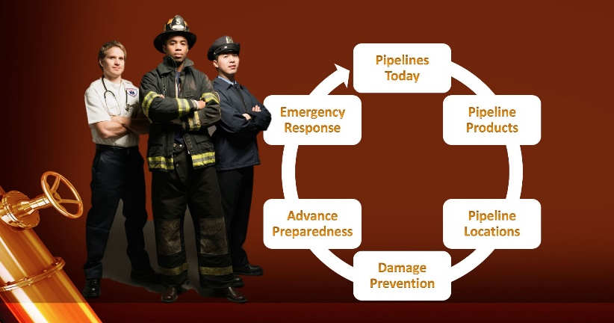
SIX LEARNING FOCUSES:
1 – PIPELINES TODAY
- Video Segment
  - Pipeline purpose and reliability
  - Integrity management and prevention measures undertaken
  - Pipeline safety and efficiency
  - The overall state of the pipeline network today
  - Obligation to report pipeline contact/strikes to operators
- Pipeline types and functions (gathering, transmission, distribution)
- Integrity management and prevention measures undertaken by operators continued
- One Segment Question
2 – PIPELINE PRODUCTS
- Video Segment
  - Product types, characteristics, leak recognition, potential hazards
(Natural Gas, Petroleum Gas, Crude Oil, Refined Products)
  - Odorization/Gate Stations
  - Migration
- History of Natural Gas Odorization – The New London Texas School Explosion
- Leak recognition, potential hazards, and emergency response continued
- Emergency Response Guidebook (ERG), website and mobile app
- Migration continued
- One Segment Question

3 – PIPELINE LOCATIONS
- Video Segment
  - Pipeline markers: types, purposes, locations, information found on, ROW’s
  - Pipeline location information
- National Pipeline Mapping System (NPMS) instructions
- County-Custom NPMS operator list results
- County-Custom NPMS Map
- Texas Railroad Commission Public GIS Viewer Instructions
- High Consequence Areas (HCA’s) definition and examples
- Two Segment Questions
4 – DAMAGE PREVENTION
- Video Segment
  - State 811 One-Call requirements, procedures and laws
  - Excavator and operator responsibilities
  - Corrosion and leak causes data
  - Damage prevention awareness
- Damage and reporting rules
- Current DIRT Report damages by state
- DIRT Report damage indicators and variables related to that state
- A first responder’s role in damage prevention
- Awareness of pipeline markers (temporary and permanent), pipeline activity, color codes
- First responders as community damage prevention advocates – risks posed to pipelines by people or environment
- Two Segment Questions
5 – ADVANCED PREPAREDNESS
- Introduction to HMCRP Report 14 (Guide for Communicating Emergency Response Information for Natural Gas and Hazardous Liquids Pipelines)
- Video Segment – Smalley Incident 911 call/dispatch
- NENA 56-007 –911 dispatch standard for pipeline emergency call intake
- HMCRP Report 14 identified incident-management inadequacies/response failures
- Dispatch call intake and first response checklist
- Dispatch – caller description checklist for determining the involvement of a pipeline
- Preplanning checklist
- Preplanning example chart and information sources
- Three Segment Questions
6 – EMERGENCY RESPONSE
- #1 priority – Public safety and environmental protection
- Video Segment – Smalley incident footage
- Initial emergency steps to take (dispatcher/responder/operator)
- Things not to do
- Planned operator response procedures
- Ignition sources and PPE (includes video clip)
- Response modes
- Appropriate methods for mitigating pipeline vapors and/or fires
- One Segment Question

